**Chemistry 1B Section 1 Worksheet**

1. What is the frequency of radiation that has a wavelength of 3.75 x 10-7 m?
2. What is the wavelength of radiation that has a frequency of 4.2 x 1015 Hz?
3. What is the frequency of radiation that has a wavelength of 5.20 x 10-11 m?
4. What is the wavelength of radiation that has a frequency of 8.11 x 1018 Hz?

[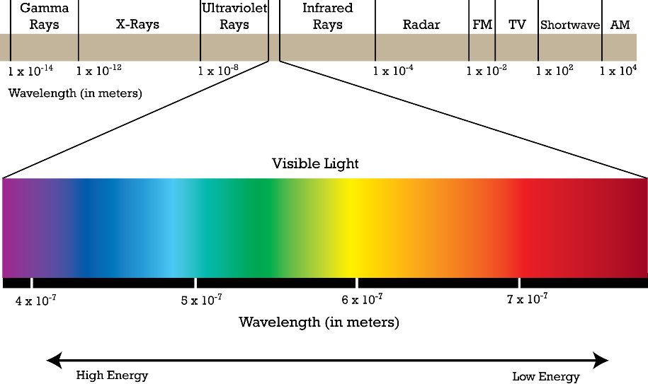](http://www.google.com/url?sa=i&rct=j&q=&esrc=s&source=images&cd=&cad=rja&uact=8&ved=2ahUKEwjXouvl0IHhAhUoZN8KHTYLAuUQjRx6BAgBEAU&url=http%3A%2F%2Fwww.pion.cz%2Fen%2Farticle%2Felectromagnetic-spectrum&psig=AOvVaw0BmVq5kAJbVcPUh_1YIrk9&ust=1552652837376143)

**Chemistry 1B Section 1 Worksheet**

1. What is the frequency of radiation that has a wavelength of 3.75 x 10-7 m?
2. What is the wavelength of radiation that has a frequency of 4.2 x 1015 Hz?
3. What is the frequency of radiation that has a wavelength of 5.20 x 10-11 m?
4. What is the wavelength of radiation that has a frequency of 8.11 x 1018 Hz?

[](http://www.google.com/url?sa=i&rct=j&q=&esrc=s&source=images&cd=&cad=rja&uact=8&ved=2ahUKEwjXouvl0IHhAhUoZN8KHTYLAuUQjRx6BAgBEAU&url=http%3A%2F%2Fwww.pion.cz%2Fen%2Farticle%2Felectromagnetic-spectrum&psig=AOvVaw0BmVq5kAJbVcPUh_1YIrk9&ust=1552652837376143)